FORMFLOW — TERRAFORM INFRASTRUCTURE DOCUMENTATION
CAPSTONE PROJECT FOR GROUP 1

1. Overview
This Terraform files provisions a single Ubuntu VM on Azure to host the FormFlow app, plus the minimum networking needed to reach it from the internet and to SSH deploy from CI/CD.
Provider: hashicorp/azurerm - v4.1.0
Region: uksouth
Naming convention: every resource prefixed with var.prefix (default being formflow)

2. Resource inventory
Resource Group = Logical container for all resources everything below lives inside it
Virtual Network = Private address space 10.10.0.0/16
Subnet = 10.10.1.0/24, where the VM's NIC lives
Network Security Group = Firewall
NSG ↔️ Subnet Association = Binds the NSG to the subnet (NSG rules do nothing until associated)
Public IP = Static, Standard SKU — the VM's internet-facing address
Network Interface = Connects the VM to the subnet and the public IP
Linux VM = Standard_D2s_v3, Ubuntu 24.04 LTS, SSH-key auth only

3. Variables
Variables were added for;
Name prefix
Vnet_address_space
Subnet_address
Subscription_id
Ssh_public_key
4. Networking & Security
NSG rules (formflow-nsg):
AllowSSH - 100 - Inbound - 22 - TCP - Allow
AllowHTTP - 110 - Inbound - 80 - Any - Allow
Everything not explicitly allowed is denied by Azure's built-in default rule that's why there's no explicit "deny all" block in the code.
Auth:disable_password_authentication = true on the VM: SSH key only, no password login possible.
5. Outputs
vm_public_ip
vm_private_ip
6. Known divergences / open items
Being explicit here is what turns "it works" into "it was designed" per Phase 0 instructions, note these rather than staying silent:
1. terraform.tfvars should not be committed.** It currently holds subscription_id and ssh_public_key in plaintext. Add *.tfvars to .gitignore; pass these as CI secrets instead when running Terraform from GitHub Actions.
2. State is local. terraform.tfstate is a local file in this build. Fine for solo work, but if teammates are also acting as infra leads, a remote backend (Azure Storage Account + container) avoids state conflicts and is worth mentioning even if you don't implement it.
7. Issues encountered & resolutions
1. VM size (size field): SKU not available in uksouth
Terraform kept rejecting the VM size initially chosen, that SKU simply wasn't offered in the uksouth region. Rather than guess repeatedly, a VM was created manually through the Azure Portal in uksouth to see which sizes actually show up as available there. Standard_D2s_v3 was confirmed available and used going forward.

Why this happened: not every VM size exists in every Azure region. availability is region-specific and isn't obvious from documentation alone.

Better approach for next time: az vm list-sizes --location uksouth --output table via Azure CLI would have answered this in one command, without needing to provision anything manually.

2. NSG SSH rule — scope of source_address_prefix
The AllowSSH rule needed a source. The real tradeoff: GitHub-hosted runners don't have a fixed IP (Actions runners are ephemeral, pulled from a large, changing Azure IP range), so scoping SSH to a single IP wasn't straightforward without maintaining a dynamic allow-list (e.g. via GitHub's published runner IP ranges, refreshed on each pipeline run).
Decision made: source_address_prefix = "*". SSH open to any source.
Why: time constraint during the build; narrowing this properly meant either fetching GitHub's IP ranges dynamically in the pipeline and updating the NSG rule per run, or standing up a self-hosted runner with a static IP, both bigger scope than the capstone timeline allowed.
Known risk, stated plainly: port 22 open to 0.0.0.0/0 means anyone can attempt SSH against the VM. Password auth is disabled (disable_password_authentication = true, key-only login), which is the main mitigation in place. This is not resolved, only accepted worth naming explicitly in the worksheet rather than leaving it implicit, since Phase 0 grading penalizes silence over acknowledged tradeoffs.

If revisited: fetch GitHub Actions' published IP ranges (https://api.github.com/meta, under actions) in the pipeline and generate the NSG rule from that list, or restrict SSH to a bastion/VPN and drop public SSH access entirely.

8. How to run
terraform init
terraform plan -var="subscription_id=<sub-id>" -var="ssh_public_key=$(cat ~/.ssh/id_ed25519.pub)"

terraform apply -var="subscription_id=<sub-id>" -var="ssh_public_key=$(cat ~/.ssh/id_ed25519.pub)"

Or supply both via terraform.tfvars (kept out of version control) instead of -var flags.
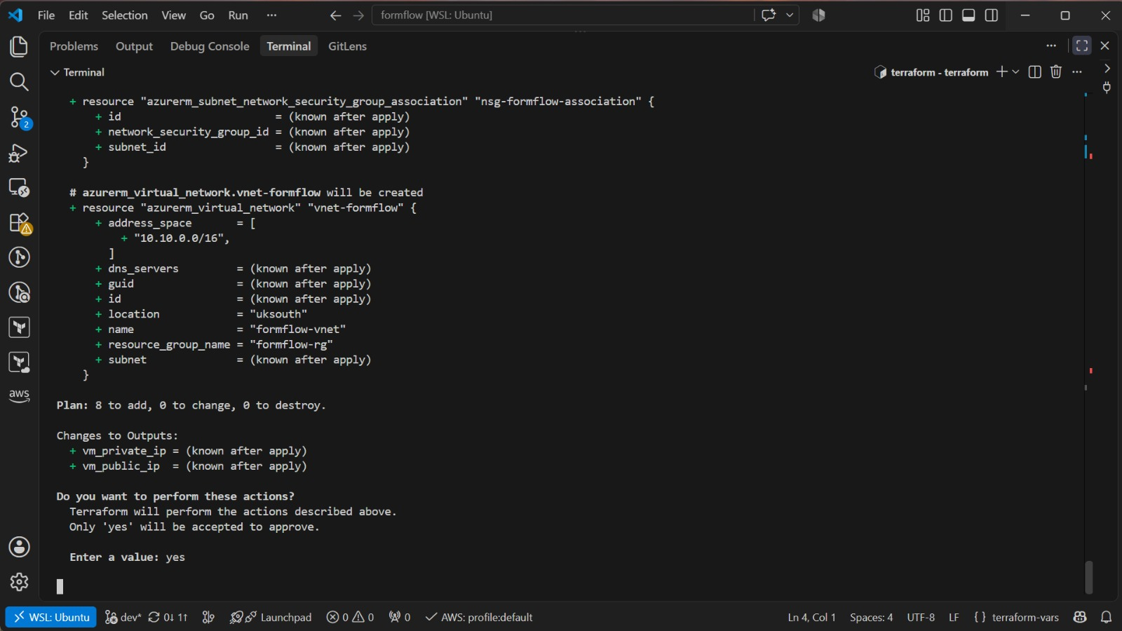
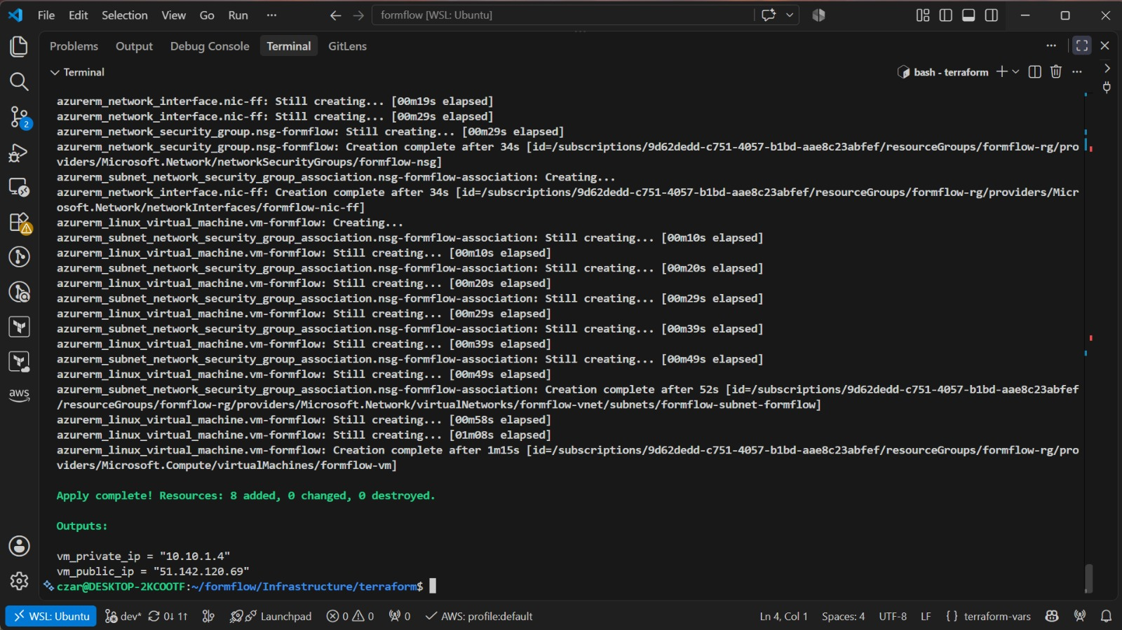
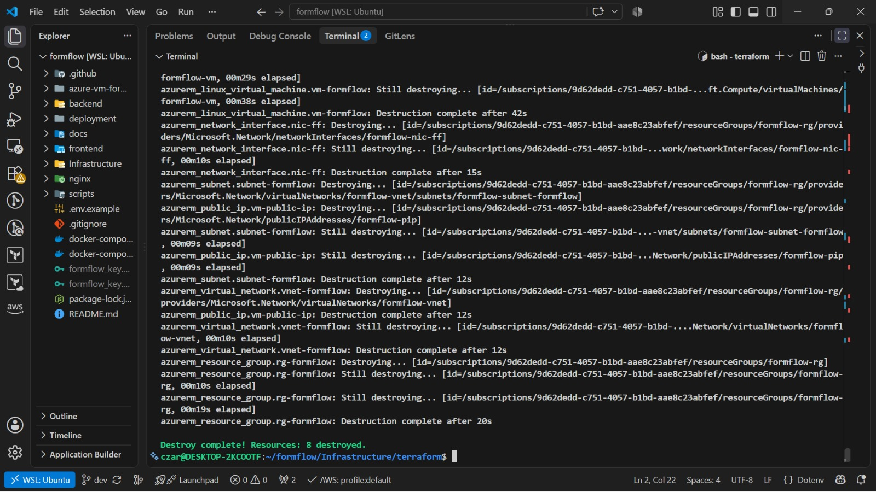
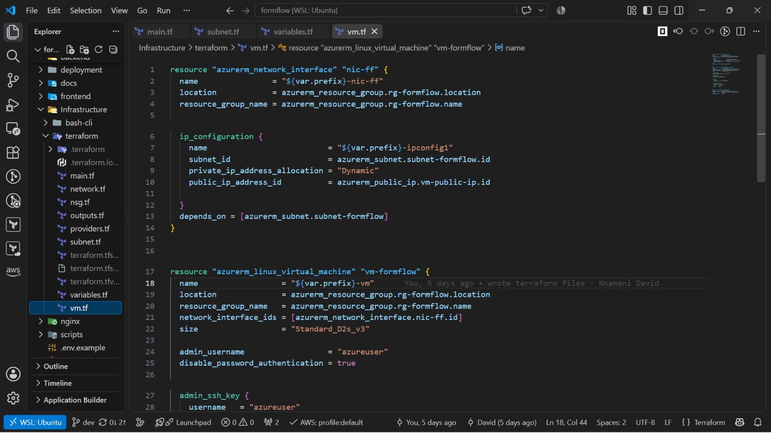
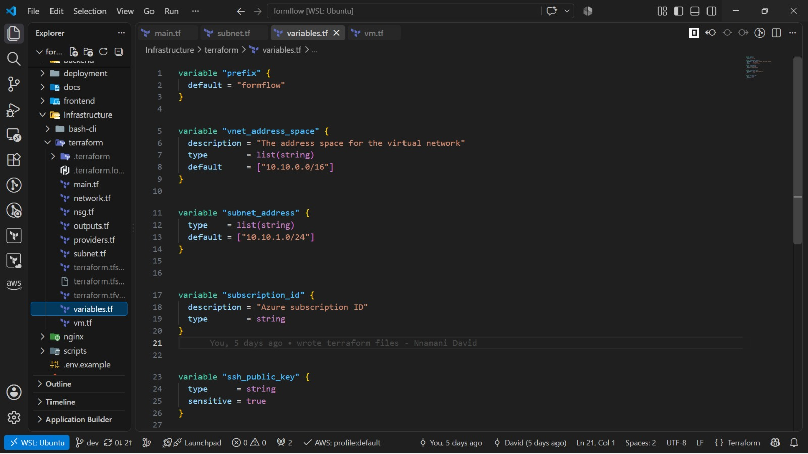

ERRORS ENCOUNTERED and How IT WAS Resolved
Challenge | Root cause | Action taken | Outcome
Compose file not detected | The file was named docker-compose.prod.yml, which Docker does not auto-select. | Used -f docker-compose.prod.yml and --env-file deployment/compose.env from the repository root. | Compose configuration loaded correctly.
Missing deployment environment files | Compose referenced deployment/*.env files that did not exist. | Created the deployment directory and local environment files; added ignore rules. | Configuration validation proceeded.
Prisma npm installation failed | Prisma engine download was interrupted by ECONNRESET. | Added retries, longer timeouts and npm cache mounts; rebuilt the backend image. | Backend and frontend images built successfully.
Prisma CLI unavailable risk | Production used npm ci --omit=dev while runtime migration used the Prisma CLI. | Ensured Prisma was available as a production dependency and used npx --no-install. | Runtime migrations no longer depended on downloads.
Backend unhealthy | Administrator seed queried User.isActive, but the column did not exist. | Added a new forward Prisma migration for isActive and rebuilt/recreated backend. | Migration applied; backend became healthy.
Frontend unhealthy | Health check called curl, but the Next.js runtime image did not contain curl. | Replaced curl with Node fetch and recreated the frontend container. | Frontend became healthy with failing streak 0.
Nginx restart loop | Nginx could not resolve frontend:3000 because the services did not share a network. | Attached frontend to the application network and recreated containers. | Nginx resolved frontend/backend and started.
Port 80 initially unavailable | Nginx was not running, so localhost had no listener on port 80. | Fixed Nginx DNS/networking and confirmed 80:80 publishing. | Public health routes became reachable.
Registration route returned 404 | Browser called /auth/register, which was routed to Next.js instead of backend. | Identified that the public API path must be /api/auth/register. | Source correction/rebuild still required or under review.
Login returned 401/500 and HTML | Authentication/backend exception and inconsistent JSON error handling. | Started tracing backend logs, API route configuration and response parsing. | Open issue under active investigation.

Error: There was inconsistency with the url names in the env. file and compose file, nginx configuration was missing in docker compose file, database was out of sync.
Solution: we renamed the compose file to docker-compose.local.yml, included nginx configuration in the compose file it was missing.

Error: The environment variables were not properly configured, consequently, during Docker build, we could not access the backend service as a result of which the browser sent request to auth/me endpoint but received a 404 response.
Solution: This error was fixed by hiding the port and routing through nginx on portal 80 which connected with Frontend on 3000 then to the backend on 5000 so that there won’t be public direct access to web service.

